Webelos Ninja Den Parent’s Meeting – Pack 426
Sept 12, 2006 8-9 pm

AGENDA AND NOTES

Bear Year Retrospective : Looking Back
- What went well last year?
- What needs improvement this year?
  - Ideas how to do that.

Webelos 1 Year : Looking Forward
- Philosophy of scouting
  - Fun fun fun
  - Character, teamwork, camaraderie, tradition, process
  - Get ready for boy scouts – keep boys interested till 6th grade
- Webelos program recognizes the transition --- cub to boy scouts
  - Boys are maturing and are curious
  - Boys are more responsible to track achievements
    - Share with boys your entries into Scouttrack.
    - Move book signatures to Scouttrack.
    - Boys pick from alternatives on achievements
  - I will expect more leadership from denners. They run the early part of the meeting (call boys to order, flag, inspection, dues, turnover to den leader).
  - On the other hand, boys are still boys….
- Rank Goals for this year
  - Webelos badge in Feb or Mar
    - 3 achievements
    - Religious, spiritual aspect
      - I NEED PARENTS TO START BOYS THIS FALL
    - Webelos and scout lore
    - Participation in den meetings.
  - Compass point emblem in May or June
    - 4 more achievements
- Scouttrack.com
  - Thanks for your active use if it last year. It keeps den time to focus on things that matter!
  - 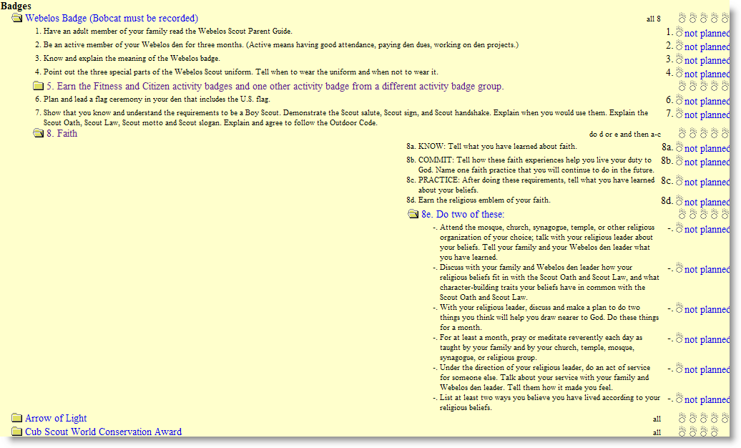
  - Discussion how to annotate scout handbooks
  - Belt loops and achievement pins for sport and academics
    - Continues, and will be part of some achievements.
  - Den leader will annotate Scouttrack and handbook for den accomplishments

- Absences from den activities
  - Some den activities are voluntary
  - If a scout can’t make a den activity, it is Akela’s responsibility to
    - Alert den leader or other leader to not expect that scout.
    - find out what achievements were covered at the time, and to do it as a family.
  - Den leader updates those achievements in scouttrack for boys who were present.

SCHEDULING
- Discussion of meeting times this year
  - Regular den meetings
    - 2nd Sundays 2-4
    - 4th Sundays 2-4
  - Outdoor camping / fieldtrips (for activity badges, and for fun)
    - Autumn Den campout – Oct 27 and 28 (includes den meeting)
    - Spring Den campout ??
    - May Pack Family Campout weekend (May 31 – June 1)
  - USS Hornet overnight May 3rd
- Den Campouts
  - Boys like outdoors (most important voted Activity)
  - Boys like camping! Why not give that to them?
  - Fall Den Campout? (November?)
  - Spring Den Campout?
  - End of May Pack Campout

VOLUNTEERING “parents (not scouts) make the pack go”
- I will continue to serve the boys and you as den leader
  - Furnish my home/garage for den meetings
  - Attend and represent you at pack committee meetings
  - Keep you informed for den activities monthly
    - Monthly email updates
    - Scouttrack calendar https://www.scouttrack.com/servlet/ScoutTrack
    - Den website: http://www.martinka.org/scouts
  - Pack emails and newsletter from Yahoo group
  - Serves as volunteer assistant pack cubmaster 2 or 3 times
  - Put in at least 12 hours on scouting per month
- Webelos 1 parents have pack obligations to
  - Sponsor the February Blue and Gold dinner (decorations, food, setup, dessert)
  - Participate with den leads with the popcorn, food, and FOS initiatives
  - Optional: Help out Becky (the Bear den leader) with the pinewood derby a bit
    - Track setup and preparation
    - Officials (inspection)
    - Food service
- Other help and support needed
- Two adults for every den function (legally and SOP)
- One adult per child for overnight functions.
- I need for you to check your car/insurance forms from last year.
- Recognition of those who help lead the pack
  - Patti Pelkey as pack treasurer
  - Wan Lee as host for Jan committee meeting
  - Openings still:
    - cubmaster, secretary, summer coordinator, volunteer coordinator

Openings at the pack level.
- Secretary – VACANT
- ASSISTANT CUBMASTER – VACANT
- CUBMASTER – VACANT
- February 25th, 2008 Host Committee Meeting – VACANT
- March 24th, 2008 Host Committee Meeting – VACANT
- May 19th, 2008 Host Committee Meeting – VACANT
- November 26th, 2007 Host Committee Meeting – VACANT
- October 29th, 2007 Host Committee Meeting – VACANT
- Roundtable Representative – VACANT
- Summertime (2008) Activity Coordinator – VACANT
- Volunteer Coordinator (a person who will do this sort of thing next year and get volunteers for the pack as needed)– VACANT
☼ → Action items from this meeting
- ☼ Please read the Parent’s guide to Webelos (p 1-22 of Handbook). Reviewing it with your scout is reqt 1 of the Webelos badge. (p 49)
- ☼ Tear out and Remove child abuse parent guide from front of Handbook. It is for your reference. Consider talking through p 14 to 17 with your scout.
- ☼ FAITH: Start your scout on spiritual or religious medal achievement. The goal is to complete it by Christmas!
  - Emblems for organized religions: http://usscouts.org/advance/cubscout/religious.asp
  - two requirements for boys in non-organized
- ☼ If you are popcorn colonel, Fitness activity volunteer, or October pack meeting setup person, please check with me!

Ninja Den Volunteer List

Den Meetings
AKELA helps Joe out by preparing and taking over parts of the meeting, and supplying simple snack for the end. BACKUP AKELA serves as requested by the AKELA or Den Leader, or substitutes for the Den Leader’s absence.
Activity | Comments | AKELA INTEREST | BACKUP
Citizen | Must for Webelos badge | Dwight | Joe
Fitness | Must for Webelos badge | Peggy
Outdoorsman | Highest vote getter at 6 | Kevin
Traveler | 2nd highest vote getters at 5 | Wan
Scientist | 2nd highest vote getters at 5 | Dwight
Artist | Crafts and creativity | Vered
Engineer | Making things work. Honorable profession too! | -----
Forester |  | Kevin
Craftsman | Wood projects (pinewood derby?) | Joe
Showman | Theatre, puppets | Vered
Naturalist | Animals in the wild | ----
Scholar | The act of process of teaching/learning | ----
Handyman | Fixing things around the house. Car, bike | Joe
Geologist | Rocks, stones, earthquakes | ----
NON VOTED AREAS
Aquanaut | Water sports and safety | Patti
Athlete | Track and field. Strength | ----
Sportsman | Belt loops for Webelos in sports | ALL DONE AT HOME | “Scoutwork”
Communicator | Secret codes, semaphores | ----
Family Member | Stuff at home. You can do this one! | ALL DONE AT HOME | “Scoutwork”
Readyman | FirstAid training and safety | Patti | Obligatory for Arrow of Light

Pack Meeting Support
I need help on certain pack meeting months. The Snack person arranges with other parents to bring and staff snack table, and organize folks to come early for room setup. The Flag person corrals and preps the boys for the flag ceremonies in the back (Joe is asst scoutmaster those months). The Skit Coordinator selects and rehearses the boys in a pack skit. Host for committee meeting just makes house available on 4th Tuesday for committee meeting. (refreshments optional)
 | SNACK VENUE SETUP COORDINATOR | FLAG CEREMONY COORDINATOR | SKIT PRODUCTION COORDINATOR | HOST FOR COMMITTEE MEETING
Aug | XX | XX | XX | Joe M.
Sep | XX | XX | XX | XX
Oct | Dwight | XX | XX | XX
Nov | XX | Wan | XX | -----
Dec | XX | XX | XX | XX
Jan | XX | XX | XX | Wan Lee
Feb | B&G see below | XX | XX | XX
Mar | XX | XX | Vered | XX
Apr | XX | Wan | XX | -----
May | Vered | XX | XX | XX
Jun | XX | XX | XX | XX

General Pack Support for the Den

POSITION | VOLUNTEER | MONTHS
Popcorn Kernel | Wan Lee | Sep-Nov
Scouting for Food Coordinator | Feli – Dwight | Nov
Overnight Reservation | Vered | Oct
Pinewood Derby | (Becky requests) | Jan
Blue and Gold Decorations | Peggu | Jan-Feb
Blue and Gold Coordinator | Patti | Jan-Feb
Room Reservations | Vered | Oct
Spring Pack Event coordination | Kevin | Pick one: skating, bowling, hike, conservation
Summer Pack Event coordination | Peggy | Pick any simple summer activity
Flag Sewer | Patti | Oct

Pinewood Derby
- The (tiny) Bear dens will put on the Pack’s Pinewood Derby this year.
- They will need some of our expert help. It is too much for four parents!

Pack General needs
List of people who have already got a volunteer position for 2007/08.
- Abukahter, Odette, = Fall Recruitment
- Abukahter, Odette = Scout a Rama
- Andrews, Johanna = August 2007 Family Picnic (completed Thanks)
- Bahr, Terri = Bowling
- Bennett, Becky = Pinewood Derby Track
- Cashmore, Marianne = Fall Recruitment
- Evard, Dwight = Small Family Hike
- Garrett, Nancy Beth = Family Camp May 2008
- Graves, LuAnn = April 28th, 2008 Committee Meeting
- Graves, LuAnn = September 24th, 2007 Committee Meeting
- Lee, Wan = Push Cart storage
- Lee, Wan = January 28th, 2008 Committee Meeting
- Mendel, Sandy = Friends Of Scouting
- Mendel, Sandy = Ice Skating
- O'Neill, Kevin = Author "Welcome to Pack 426
- O'Neill, Kevin = Cake Auction
- Pelky, Patti = Treasurer
- Reed, Evelyn = Committee Chair
- Reed, Evelyn = Yahoo Group Moderator
- Rustagi, Rachna = Toys for Tots
- Saltzman, Deb = UNICEF Collection
- Shanahan, Dave = Friends Of Scouting
- Weisner, Christine = Newsletter Editor
- Weisner, Christine = Uniform exchange
- Williams, Julie = Advancements
- Sadowski, Mike = Quartermaster
Peggy Ngai = Summer coordinator

